Little SPARK: Simple Play Adaptations to Reference for Kids

Crayon Rocks
Description: | Image:
These safe, all-natural crayons are made of soybean wax tinted with natural mineral powders. Packed in a drawstring bag, this set contains 16 vibrantly colored crayons.  Purchasing Information | 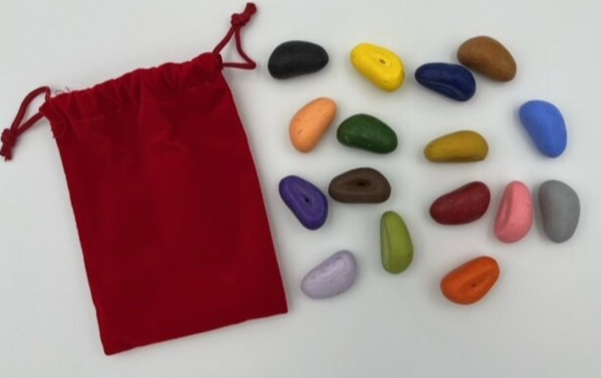

Who Might Benefit?
Those who demonstrate motor challenges and can’t hold a writing/drawing tool in the typical way.
Why Use?
The stone-shaped crayons provide an opportunity to develop and strengthen grasp, draw, color, and create original artwork.
Instructions for Use: | Adaptation Ideas:
Environmental Considerations  - Use in any environment with a hard surface to support the writing or drawing material.  Positioning & Alternate Positioning  - Use in any position; seated, standing, on the floor, with a slanted surface, on an easel/wall.  Basic Play/Use Extended Play/Use  - Copy, draw, and create Sort, match, and identify colors.  Play/Use with Others  - Shared drawing, coloring, copy (i.e. “I draw, you draw”). | Simplify It  - Offer fewer color choices.  Contain It  - Place paper and crayons on cookie sheet or tray so that crayons remain close to the drawing activity.  Add Sensory Cues  - Draw on paper on top of a sheet of sandpaper for sensory feedback.  Communication Supports  - Visual supports like communication cards and social narratives can help a child communicate their feelings.  Alternative Uses  - Create a color matching game- crayon rocks to color picture cards or color words.

Words to Encourage Play/Use
Blue  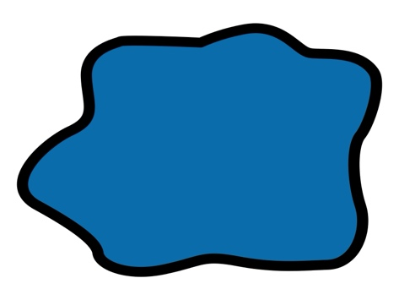 | Red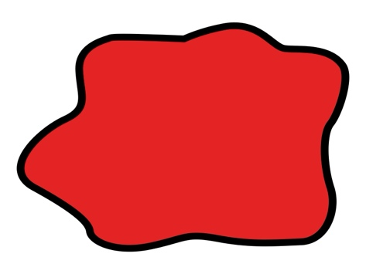 | Yellow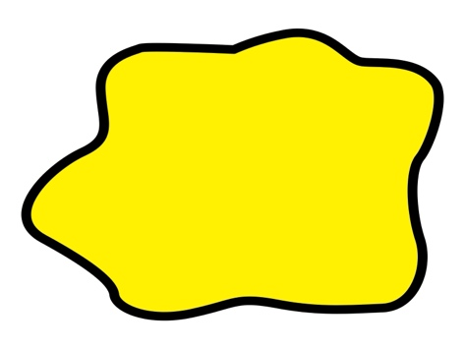
Green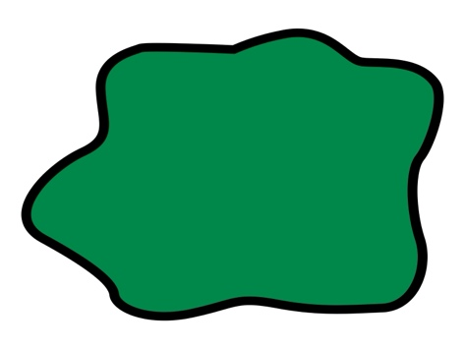 | Orange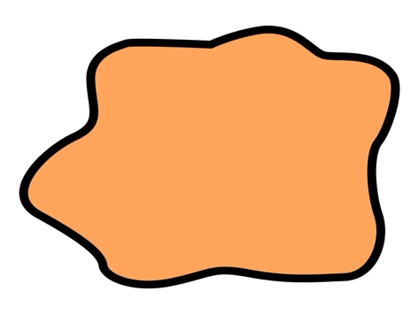 | Purple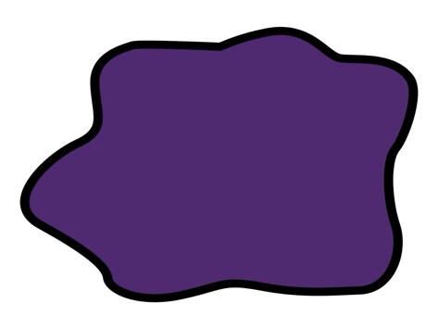
Black | Draw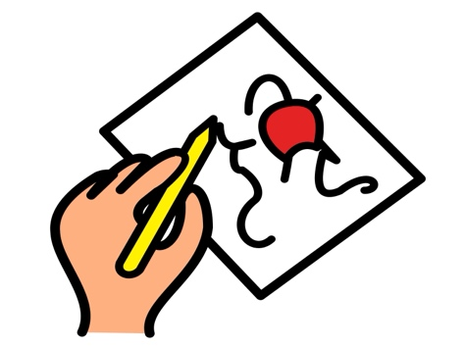 | Paper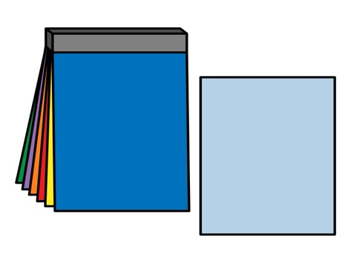
*”Adaptations” adapted from: Haugen’s Modes for Adapting Toys based on materials from the "Let's Play" Project at the University of Buffalo
PCS is a trademark of Tobii Dynavox, LLC. All rights reserved. Used with permission.

